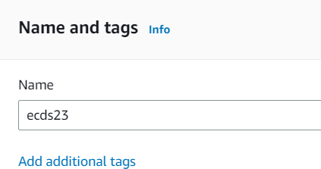ASSIGNMENT NO-07

* **Problem Statement:- Upload A static website in EC2 server**.
* **Steps:**-
  1. Login to **AWS** account and go to search option and search EC2.At the left sight in the “instances” click instances .

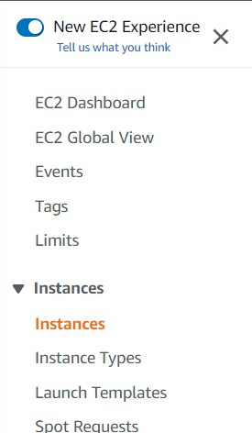

* 1. Click on “Launch instances” and enter the name(ex-ecds23) ,click hardware “Ubuntu”, check the hardware if it is 64-bit or not and then check if the software is t2.micro.

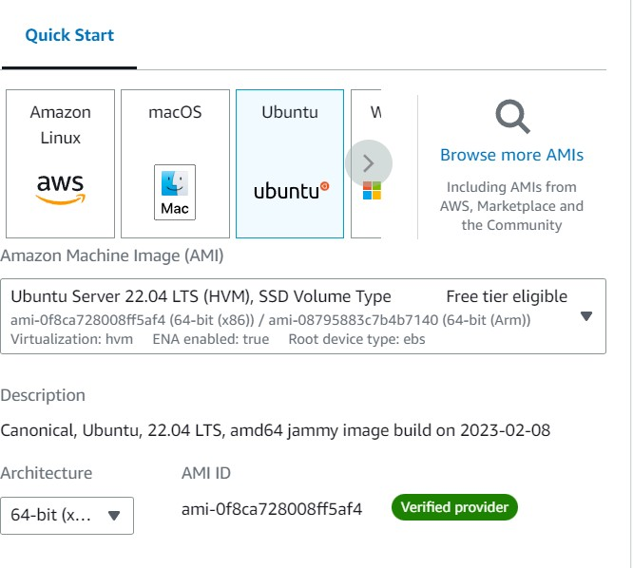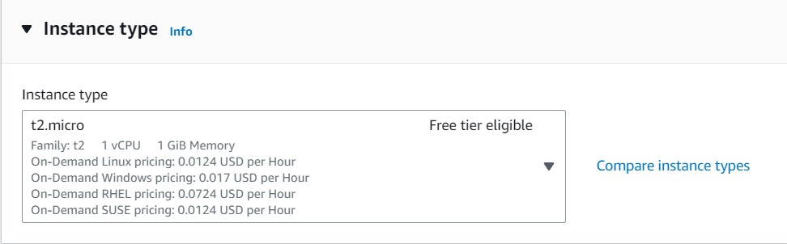

* 1. In “key pair” section click on “create new key pair” and give a key pair name which is not used before(ex-key003) and click on click key pair.

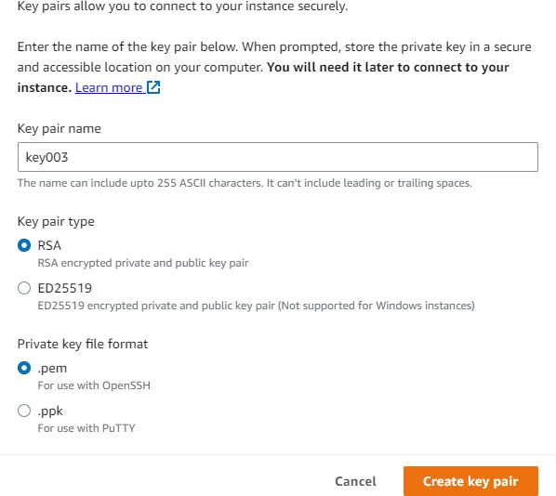

* 1. Check allow **SSH,HTTPS,HTTP** and then click on launch instance and ec2 server is created .

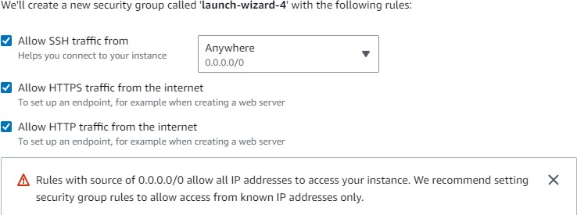

* 1. 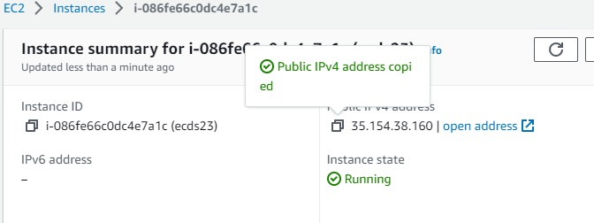Click on instance id and copy “Public IPv4 address” .
  2. Now install Bitvise SSH client and open it .

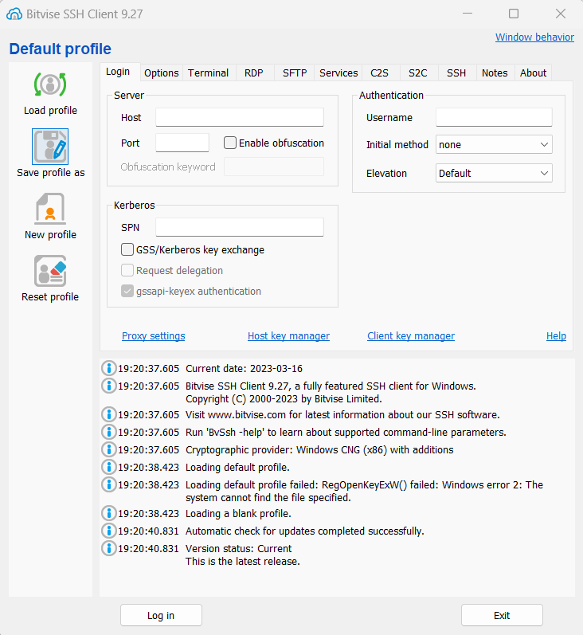

* 1. Copied IPv4 address is pasted on “Host” section and in Authentication section in In Username give **Ubuntu** and in initial method select **public key**.

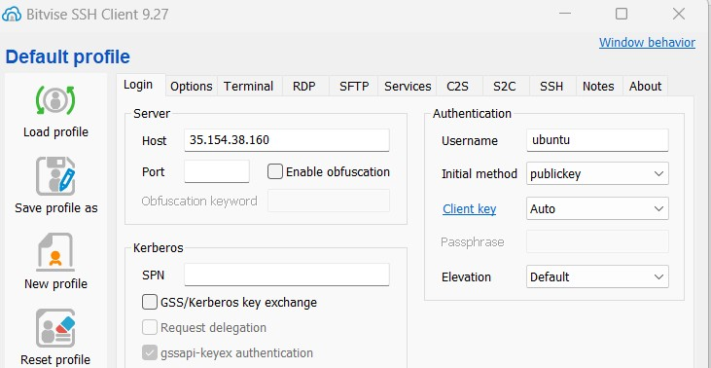

* 1. Now click on client key manager and import that downloaded **.pem** file(ex- key1234.pem). and now in client key select global1 if the location name is global1.

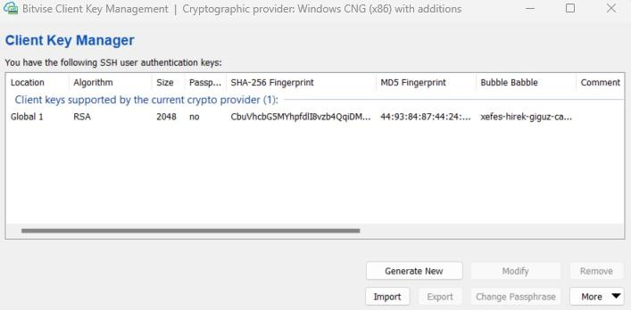

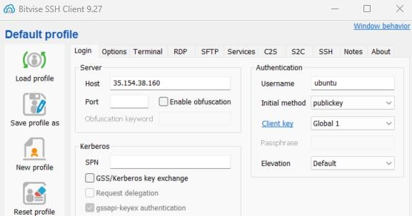

* 1. Click on login and accept and save .

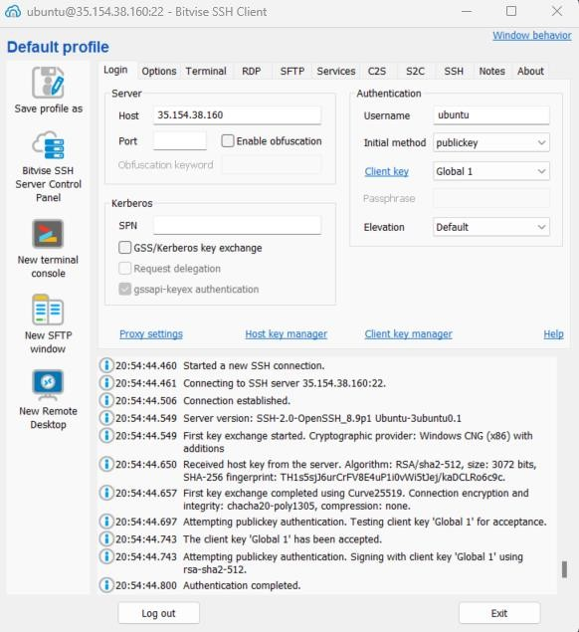

* 1. Now,click on “New Terminal Console” and write three command “sudo apt-get update”,”sudo apt-get upgrade”,”sudo apt-get install nginx”.

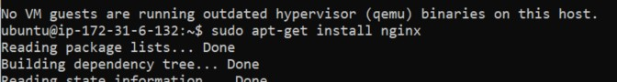

* 1. After installing it now type cd .. two times to go back to root .

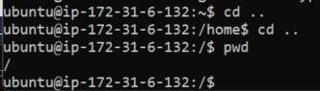

* 1. Now go to “www” by typing cd var and then cd [www.](http://www/)



* 1. Now type sudo chmod 777 html to give all permission.



* 1. Now go to **New SFTP window** and in Remote files go to html section and copy all

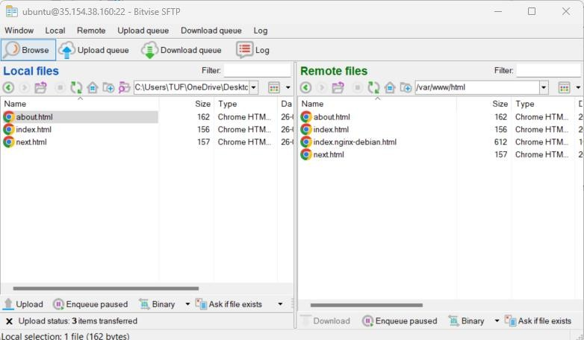.html files(about.html,index.html,next.html)and paste it to the html section.

* 1. Now copy the the IPv4 address and paste it in different tab and we can see the webpages are successfully uploaded through EC2.

